- The sinking of the Titanic in 1912 prompted the invention of sonar (standing for Sound Navigation And Ranging). A sonar system sends out a pulse of sound through water and then listens for the reflection. From the time it takes the sound to return and the change in frequency of the returning pulse the sonar system can calculate the distance to objects and their speed.
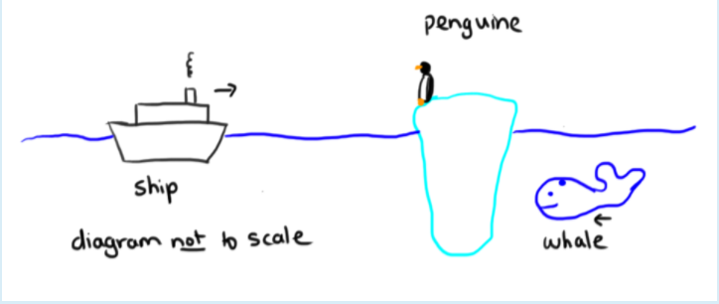
A ship with a sonar system installed sends out a sound wave pulse with a frequency of 8217 kHz. Sound waves travel through seawater with a speed 1526 m/s. The ship is 4.78 km in front of an iceberg.
- How long would it take the pulse to travel from the ship, to the iceberg and back?
t=? (s)
- What would be the wavelength of the sound wave as it travelled away from the ship through the water? λ=? (m)
- The ship is travelling through the water towards the iceberg at a speed of v_{ship} = 46.0 km/h. There is a penguin sitting on the iceberg who puts his head under the water. What would be the frequency of the sound detected by the penguin? f_{penguine} =? ( kHz)
- The ship detects the pulse reflected from the iceberg. What is the difference in frequency between the reflected pulse and the pulse sent out by the ship?
f_{reflected} – f_{transmitted} = ? (kHz)
- A large whale lurking behind the iceberg swims out from behind the iceberg and towards the ship with a speed of 5.57 m/s. The sonar signal is now reflected from the whale. What is the change in the frequency detected by the ship now?
f_{reflected from whale} – f_{transmitted} = ? (kHz)
- What is the relative velocity of the ship to the whale? v_{ship} = ? (m/s) to the right

- The speed of light in air is 2.998 × 10⁸ m/s. A ray of light is shone onto a semicircular prism as shown in the diagram below. The prism is made from glass with a refractive index 1.560.
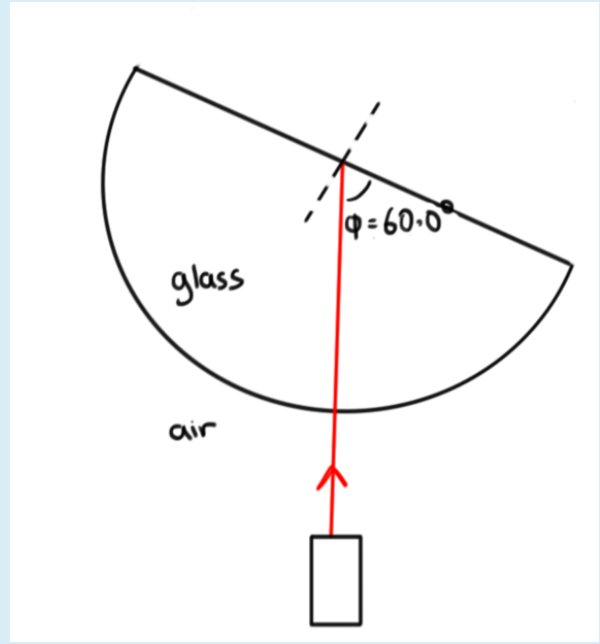

- What is the speed of light inside the glass? v=?(m/s)

- Some of the light ray exits the prism through the straight side. What angle does this exiting ray make with a normal drawn to the straight side? ?$°$

- The prism is now slowly rotated so that the angle, Φ, changes. What is the value for Φ for which light will cease to leave the prism? Φ = ?$°$

- If the prism (with ϕ remaining at the angle you calculated in the last question) is now immersed in water with a refractive index of n = 1.343 would light leave through the straight side? ( Yes or No)

- A backyard pool is 14.8 m long. For fun Sally uses a board to create waves. Sally investigates the effect these waves have on Susan who is floating on another board near the middle of the pool. Sally notices that the waves travel with a speed 7.2 m/s. If Sally moves the board up and down (ie. through one complete oscillation) every 0.77 s what wavelength does Susan observe?
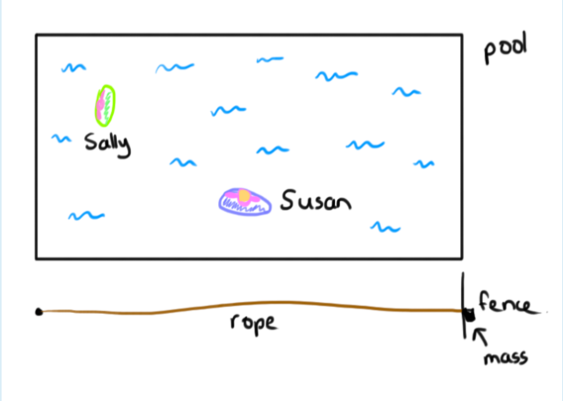

- Wavelength = ?(m)
- Sally notices that when she moves the board at certain speeds standing waves are produced. When a standing wave is established does Susan (who remains above the same point on the bottom of the pool) move up and down?
Choose the best answer.
Select one
- Maybe, it depends on exactly where Susan is in the pool.
- No, as it is a standing wave Susan is stationary.
- Yes, Susan will move up and down.

- Sally sets up a standing wave with two peaks and two troughs (these alternate with time, so the peak becomes a trough and then a peak again) along the length of the pool (there is no movement at the two ends of the pool). The wave speed remains the same, what period is Sally moving the board with now? T= ? (s)

- To investigate this a little further Sally ties a mass to the end of a rope with a linear density of 10.0g/m (grams per meter) and runs the rope above the ground along the length of the pool. She hangs the end of the rope with the mass attached over a bit of fencing at the end of the pool. The weight of the mass creates tension in the rope. Sally now sets up a standing wave in this rope with the same number of crests as the wave in the pool (the ends of the rope, aligned with the ends of the pool, do not move). Sally finds that she needs to apply a frequency of 7.7 Hz to get the rope to move in this way.
What mass is hung from the end of the rope? M=?(kg)

- An eagle flies towards the north west with a speed of 82.9 km/h. A rabbit on the ground sees the eagle and runs towards the south at a speed of 35.2 km/h. What is the relative velocity of the rabbit to the eagle?
(1) Magnitude: ? (km/h)
(2) Direction: at an angle ?$°$ (write down a number from 0-90$°$)
- Direction (choose one from below)
- North of east
- North of west
- South of east
- South of west

- A mass 4.47 kg is hung from a spring. The mass is pulled down a short distance and released, it oscillates with a frequency f = 1.315 Hz.
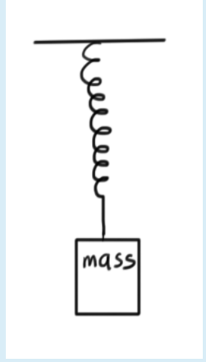
- What is the spring constant for the spring? k= ? (N/m)
- An additional 4.47 kg is added to the spring. By how much does the spring extend when this mass is added? ?(cm)
- The spring with the additional mass still on it is pulled down and released. How many times does the spring oscillate in a minute? ?(times)

- Use the pencil and mirror in the diagram below to answer these questions. It would be a good idea to print or display the image as large as you can in order to mimimise your uncertainties.
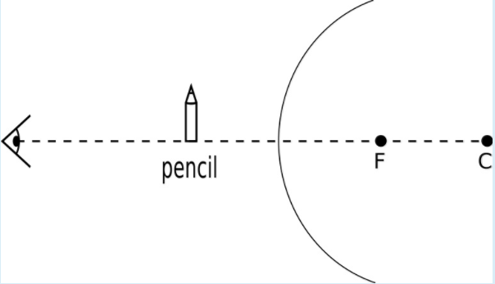
- This mirror produces a (Real?/Virtual?) image of the pencil
- This is a (Concave?/Convex?/Plane?) mirror
- Magnification (m) can be calculated using:
$$m=\frac{image height}{object height}$$
The magnification is negative if the image is upside down and positive if the image is the right way up. Calculate the magnification of the mirror above:
m=?

